DAC Circuit

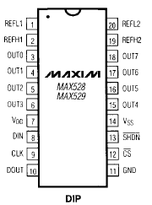
- Use MAX529 because it may use +5V supply only (while MAX528 needs +15V supply)
- See p11 of datasheet to see the function of each pin.
- We will make the reference minimum voltage 0V and the reference maximum voltage +5V.
Pin | Pin Number | Purpose | Connect to
VDD | 7 | +ve terminal of supply | +5V
VSS | 14 | -ve terminal of supply | 0V
GND | 11 | Ground | 0V
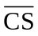 | 12 | Active Low Chip select | SPI slave select (PS7)
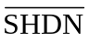 | 13 | Active Low Shutdown | +5V
REFL1 and REFL2 | 1 & 20 | -ve terminal of reference | 0V
REFH1 and REFH2 | 2 & 19 | +ve terminal of reference | +5V
DIN | 8 | Serial digital data input | SPI master data out of HC12 (PS5)
CLK | 9 | Clock | SPI clock out of HC12 (PS6)
OUT0-OUT7 | 3-6 & 15-18 | Analog output | To processes

- See p14 and 15 of datasheet to understand how to program the IC
